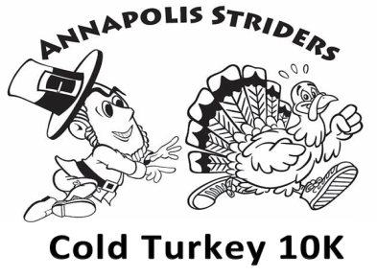

20th Year!
Sunday, November 18, 2018
After a successful return in the 19th year, frozen turkeys for first place are back again
along with Turkey trophies and medals for second and third place!
Awards given out in 5 year intervals
Arundel Middle School – Inside the Gymnasium - 1179 Hammond Lane, Odenton, MD 21113
Race begins at 8:00 am, same start line and finish line as last year
Complete all information & Mail by Wednesday, November 7, 2018
Or Register Online by 11:59 pm Wednesday, November 7, 2018
Price: Pre-registration with a guarantee premium: $35.00 Pre-registration with no premium: $30.00
Race Day $40.00 by Check only (no cash – and no guaranteed premium)
Make checks payable to: Annapolis Striders, Inc.
No Refunds or Transfers will be granted for this race.
Return to: Donna Harten, 306 Sharon Drive, Pasadena Maryland, 21122.
PLEASE PRINT
Last Name:___________________________________ First Name:_______________________________
Date of Birth:_____________________ Age on Race Day:_______________ Gender:________________
Address:______________________________________________________________________________
City, State, Zip:______________________________ eMail Address: ______________________________
Emergency Contact:__________________________ Emergency Contact Phone #:___________________
RRCA Club Affiliate: _____________________________________________________________________
Race Day Worker: Yes________ No________ Annapolis Strider 10K Class: Yes________ No________
WAIVER and RELEASE: I know that running is a potentially hazardous activity. I understand that I should not participate unless medically able. I assume all risks associated with involvement with this race/event, including but not limited to falls, contact with participants, the effects of weather, including high heat and/or humidity, the condition of the course and/or road, and traffic on the course, these risks being known and appreciated by me. I understand that headphones, bicycles, wheels of any kind, animals, baby joggers or strollers are not permitted. Having read this Waiver and Release, knowing these facts, and in consideration of my being accepted into this race/event, I, for myself and anyone entitled to act on my behalf, waive and release the Annapolis Striders, the Road Runners Club of America, all sponsors and hosts, and their representatives and successors from all claims or liabilities of any kind arising from their negligence and/or my involvement in this race/event.
Participant’s Signature (or parent if under 18) ________________________________________________________

